Component Diagram
The diagram models the structural architecture of the NBP Analytics application, illustrating the static dependencies and data flow between UI components, core utility modules, and the external NBP Web API. The structure is separated into three main layers: the entry/routing layer, the feature-specific panels layer, and the core business logic layer which handles web requests and calculations.
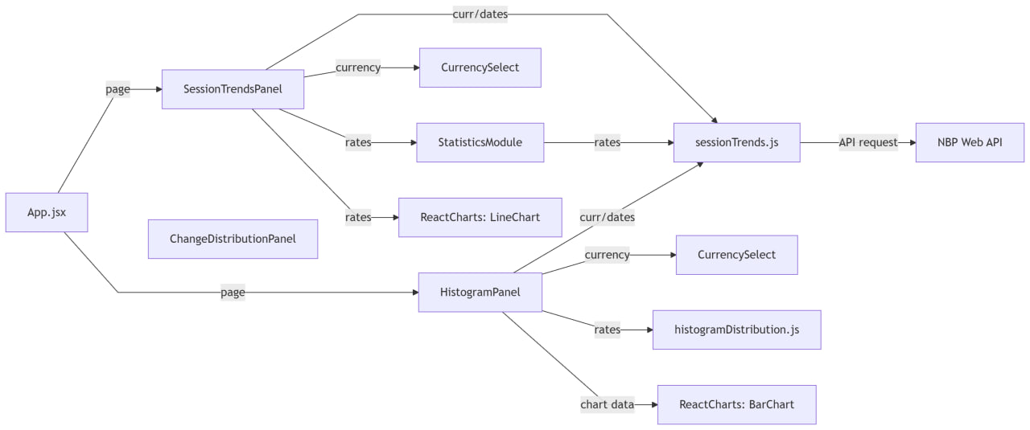

Application Initialization and Page Selection
The entry point of the application structure is App.jsx. It acts as the orchestrator of the main layout, maintaining the active page state and rendering the appropriate view. The flow splits from App.jsx based on the selected page state, directing data flow and component instantiation either to the SessionTrendsPanel or the HistogramPanel. Additionally, ChangeDistributionPanel is depicted in isolation. It exists in the codebase as an independent, fully tested module, but is not currently imported or active in the main application shell.

Session Trends Panel Workflow
The SessionTrendsPanel is a feature component that manages the workflow for analysis of currency exchange rate trends. It has four direct dependencies. First, it uses the shared CurrencySelect component to specify the selected currency. Second, it feeds the retrieved rates array into the StatisticsModule to perform mathematical analytics. Third, it forwards the rates to ReactCharts: LineChart to visualize the historical trend line. Finally, it communicates with the sessionTrends.js core service, sending curr/dates parameters to fetch the rates. The StatisticsModule itself is connected to sessionTrends.js, to which it passes the rates array to invoke core statistics functions (such as standard deviation, median, and mode) and render badges.

Histogram Panel Workflow
The HistogramPanel manages the monthly and quarterly exchange rate change distribution workflow. Similar to the trends panel, it uses a local instance of the shared CurrencySelect component to set the currency configurations. To handle API fetching and data range resolution, it communicates with the sessionTrends.js core service by providing currency/date parameters. On receiving the rates, it sends the raw rates array to histogramDistribution.js to perform daily percentage change calculations and group the results into 0.5% bins. The final processed chart data is then supplied to ReactCharts: BarChart for visual rendering.

Core Services and External API Integration
The core business logic layer is centered around sessionTrends.js, which serves as the data client and service layer for the entire application. It receives inputs (rates and currencies/dates) from both the SessionTrends and Histogram modules to execute data fetching, normalization, and mathematical analysis. sessionTrends.js interacts directly with the external environment by sending an API request to the NBP Web API endpoint (https://api.nbp.pl) to retrieve JSON formatted exchange rate series. This acts as the final terminal link in the component graph.

